Stations of the

Cross

for Our Time
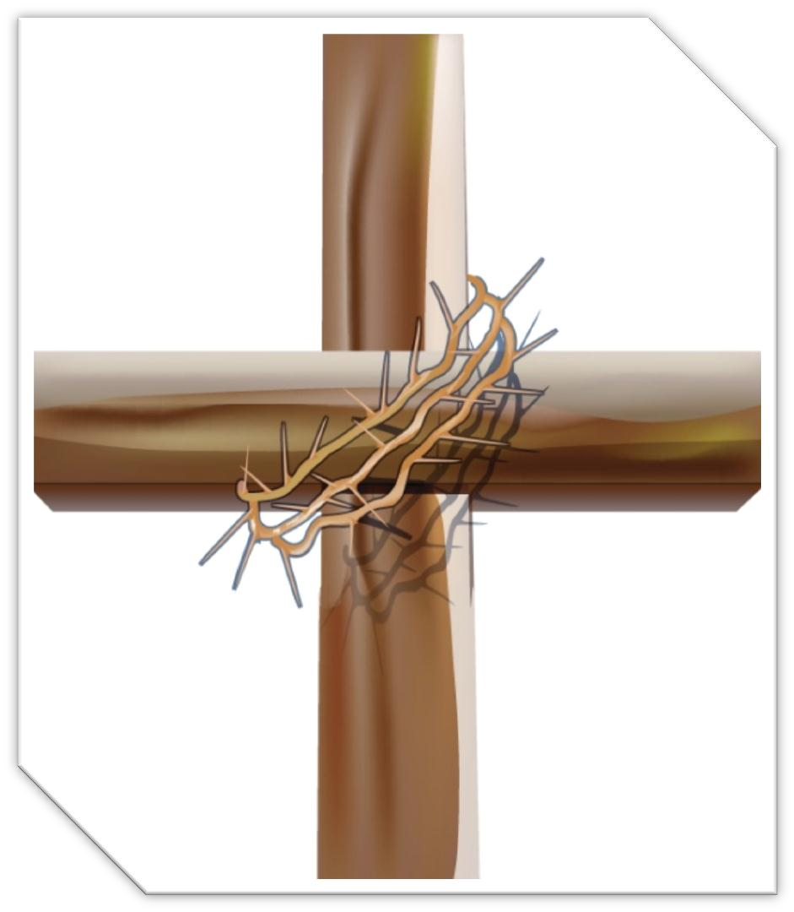

1: Jesus is Condemned to Die

We Remember the Cross of Jesus  Response: | 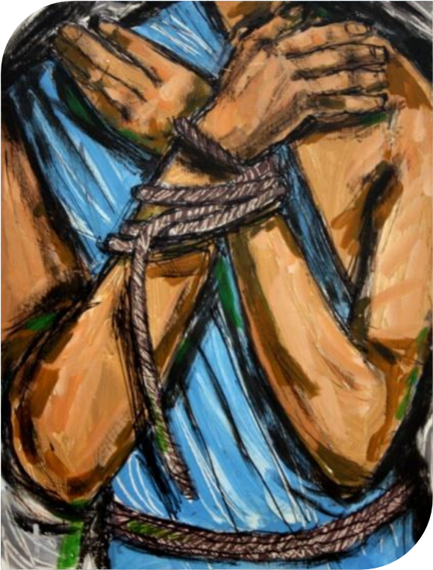  Jesus was captured at night, taken away by soldiers, stripped of his garments, interrogated, tortured, crowned with sharp thorns and now handed over to be condemned to death by Pontius Pilate – death on a cross  We adore you O Christ, and we praise you, because by your Holy Cross you have redeemed the world
We Name the  Crosses of Today | Jesus is condemned unjustly by those who did not  understand him and by those who were frightened of what he did and said. Perhaps they sensed that this man could make a difference, that he could turn their world upside down.  We continue to condemn people unjustly today. People are condemned because of the colour of their skin, their gender, their beliefs, because they are born with a disability, because they don’t conform to our way of thinking, the list is endless. There are also the people who have been justly condemned, who have been found guilty, served their sentence and asked for forgiveness. Does our society really forgive; really believe that people can change, or do we continue to condemn them over and over again?
We Pray | Jesus, what a terrible injustice to see you condemned to death. Your own people, the Roman judges and the soldiers didn’t recognise that you were the Son of God. Give us the grace to see, respect and love you in all people, both innocent and guilty. Change our hearts that we may see with new eyes those we might otherwise condemn
 | Lord in Your Mercy
Response: | Hear our Prayer

2: Jesus Takes Up His Cross

We Remember the Cross of Jesus  Response: | 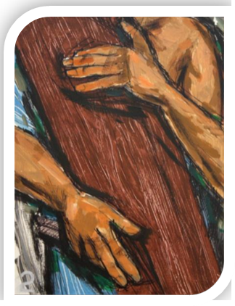  Jesus was led away carrying, the cross by himself. A cross is not just a piece of wood, it is everything that makes life difficult. Jesus carried the crosses of his life without complaint, as a poor person and as an itinerant prophet. In the calm and courageous way, he put up with the threats of the Pharisees and the lack of understanding of his own disciples. In the way that he carried all the burdens of his life but, in particular, the way in which he carries this awful, final burden, he transforms the cross from a symbol of condemnation into one of liberation.  We adore you O Christ, and we praise you, because by your Holy Cross you have redeemed the world
We Name the  Crosses of Today | There are burdens that we all carry, some are very  obvious and others we take great care to hide. There are the burdens of illness, pain and disability, of old age, dependence, and caring for someone who no longer knows who we are. There are the burdens of constant fear, of loneliness and of isolation. The invitation of Jesus on the cross is to hand over these burdens to him.
We Pray | May we see your presence Lord in all the burdens we carry today. Help us to share our burdens more freely, not to be afraid to acknowledge our fears and our pain. May we be more aware of the crosses that others bear and make time to alleviate their burden. May your face shine on each one of us through the crosses we bear.
 | Lord in Your Mercy
Response: | Hear our Prayer

3: Jesus Falls for the First Time

We Remember the Cross of Jesus  Response: | 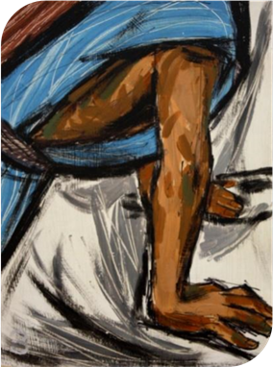  Jesus falls. Here Jesus shows us that being heroic does not mean staying on one’s feet at all costs. Being heroic means getting up again after falling and starting off on the road chosen. Human beings will never resign themselves to stay flat on the ground. Like Jesus, they will get up again, pick up their crosses and keep the lack of understanding of his own disciples. In the way that he carried all the burdens of his life but, in particular, the way in which he carries this awful, final burden, he transforms the cross from a symbol of condemnation into one of liberation.  We adore you O Christ, and we praise you, because by your Holy Cross you have redeemed the world
We Name the  Crosses of Today | Look at Jesus fall under his cross. He might have  fallen into the gutter or be slouched into a doorway on skid row. He doesn’t look much like God there, but he didn’t look like God when he fell into the dirt on the way to Calvary either. The crowds look on with disdain at this man whom they see as a sinner, who has been condemned to death by the authorities.  Like the crowd, we often have only condemnation and rejection for those we see as sinners. We judge them without knowing about their trials, scourging and crowning with thorns. Do we even suspect the part we might have played in knocking them down? What do we do to help them?
We Pray | Jesus, it’s easy to see your image in saints. Help us to see you in the sinners too. You had a place in your heart for the divorced Samaritan woman, Zacchaeus, the good thief, and for those who crucified you. Give us this same compassionate heart.
 | Lord in Your Mercy
Response: | Hear our Prayer

4: Jesus Meets his Mother

We Remember the Cross of Jesus  Response: | 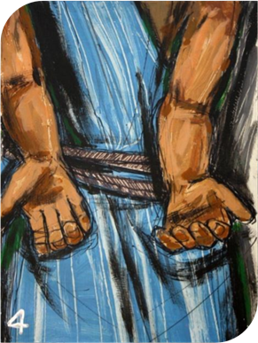  When Jesus and his mother meet they just look at each other – words cannot express how they feel. What he saw in his mother’s eyes must have hurt him more than the raw pain of his wounds. This for Jesus is the most painful  time of all. This is his bereavement.  We adore you O Christ, and we praise you, because by your Holy Cross you have redeemed the world
We Name the  Crosses of Today | Jesus carries the heaviest burden of the loss of his  crosses of today: family; the sundering of the earthly, loving relationship between mother and child. This was not of his making. The violence inflicted upon him etched into the very heart of his mother, as she watched the agony of her son. We see Mary’s pain in the mothers and fathers who watch their children giving up their life to drugs, addictions and suicide, in the women and men who suffer violence and the ongoing threat of violence in their home from spouse or  child. We see Mary’s pain in the child coping with the  breakdown of a parent’s marriage, in the couple trying  desperately to rebuild their relationship and family anew.
We Pray | Jesus, we remember the gaze that rested between you and  your mother. In that moment of pain there was also a  moment of deep and enduring love. Jesus, give us the  courage to bring that love into the deepest recesses of our  homes, to our children and to our spouses, to those places  of fracture and disharmony in our circle of relationships
 | Lord in Your Mercy
Response: | Hear our Prayer

5: Simon Helps Jesus

We Remember the Cross of Jesus  Response: | 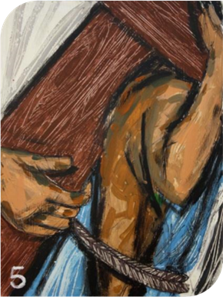  Simon the Cyrene, a stranger in  the city, did not know Jesus. But that did not matter. What matters here is that in this moment of need Simon was capable of lending his shoulders to one whose own had given out, of offering his strength to one who had nothing left, of taking on himself the cross, which Jesus could no longer carry.  We adore you O Christ, and we praise you, because by your Holy Cross you have redeemed the world
We Name the  Crosses of Today | Look at Jesus who lies hidden and unknown under our crosses of today: beneath every person in need. Across our world we see human suffering in the faces of strangers, in the faces of those struggling for democracy in the Middle East and beyond, in the faces of those dealing with the loss of life and destruction of property. People we know of, but do not know, must live with the aftermath of the ravages and destructive forces of nature – coping with floods and drought, with the devastating effects of climate change…
We Pray | Lord, help us to grasp our opportunities to be a Simon in our world. In those times when we can help, let us have the generosity to do so. May we continue the spirit of Simon through our support of all who work to alleviate suffering in our world. Lord, may we have the humility to accept all the Simons along our road who reach out to help us in our moments of need.
 | Lord in Your Mercy
Response: | Hear our Prayer

6: Veronica Wipes the Face of Jesus

We Remember the Cross of Jesus  Response: | 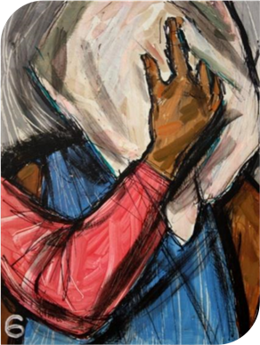  Veronica was so moved by the  sight of Jesus suffering that she  courageously moved out from  the crowd to wipe the blood and  sweat from his face with a towel.  She was rewarded when the  image of his face was transferred to the towel. It is a suffering face, disfigured with wounds. Yet this is the only image of himself that Jesus chose to leave with us.  We adore you O Christ, and we praise you, because by your Holy Cross you have redeemed the world
We Name the  Crosses of Today | Today the visible face of Christ, the Church, stands before us still wounded and disfigured; disfigured by its own sins of abuse of children and power, and creased with the wounds of hurt and betrayal. The face of Christ calls us to look upon and heal the sin of our Church.
We Pray | Jesus, give your wounded Church the courage of Veronica so that we may wash the face of Christ clean from the disfigurements of our sin. Help us to bring healing to the scars that hide the beauty of your face to our world. Give us the faith to continue to build your Church as a visible sign of your love and compassion.
 | Lord in Your Mercy
Response: | Hear our Prayer

7: Jesus Falls for the Second Time

We Remember the Cross of Jesus  Response: | 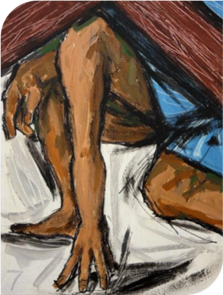  Stretched to breaking point by his awful scourging, bowed under the weight of the cross, worn out by the abandonment of all his friends, Jesus stumbles again.  We adore you O Christ, and we praise you, because by your Holy Cross you have redeemed the world
We Name the  Crosses of Today | All around us people are overburdened by the crosses they  carry; they struggle and sometimes fall. There are those who have lost their jobs and feel that they have little hope of finding another, those who live with the prospect of unemployment, and those who struggle to keep others in work. There are those who suffer because of failures in our financial, health and political systems. Jesus is with each one of us however we fall and there he chooses to love and save us.
We Pray | Jesus, from deep within yourself, you found the courage and strength to get up once again and continue the journey. Give us your strength to keep going even when hope is dim.
 | Lord in Your Mercy
Response: | Hear our Prayer

8: Jesus Meets the Women of Jerusalem

We Remember the Cross of Jesus  Response: | 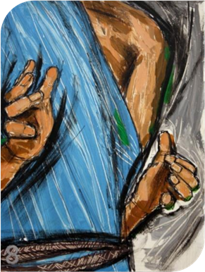  The women of Jerusalem wept when they saw how Jesus suffered. Jesus recognised their distress, he broke his silence for the first time, spoke to them and said, ‘Daughters of Jerusalem do not weep for me. Weep for yourselves and for your children’  We adore you O Christ, and we praise you, because by your Holy Cross you have redeemed the world
We Name the  Crosses of Today | Look at Jesus and listen to his message for us today.  Weep for the children who are abused.  Weep for the women who are victimised.  Weep for men and women who suffer from the tyranny of today’s body image that controls their lives and prevents them from feeling lovable.  Weep for the young who cannot find a job or a way in life.  Weep for the old who are forgotten.  Weep for people who starve in the shadow of abundance. Weep for people who are homeless, in exile or seeking refuge.  Weep for them.
We Pray | Lord, open our hearts to the suffering of all people in our world. Give us the generosity of spirit to help us recognise their pain, the courage to challenge the systems that place intolerable burdens on them and the compassion to support them.
 | Lord in Your Mercy
Response: | Hear our Prayer

9: Jesus Falls for a Third Time

We Remember the Cross of Jesus  Response: | 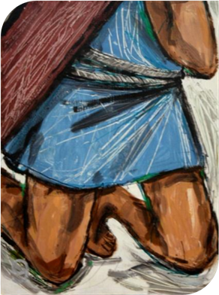  Jesus falls for a third time, broken and exhausted physically and emotionally. Lying on the ground, Jesus must decide – does he get up once more or does he just stop and give up? We see him rise again, and with all his power he continues on his journey. Jesus shows us that we can go on, even if nobody else thinks that it is possible.  We adore you O Christ, and we praise you, because by your Holy Cross you have redeemed the world
We Name the  Crosses of Today | Many in our world today feel that they are at that moment of final falling, that their burden is too much to carry. They cannot bear any more. Crushed by the weight of their cross they feel unable to get up, unable to go on. Some may look for relief in addiction. Some may look to escape through suicide.  In Jesus we find our hope and our encouragement.  The third fall of Jesus reminds us that even in our moment of complete helplessness, or our experiences of depression, in our own Calvary, we can stand up again. Jesus is with us and Jesus is our strength.
We Pray | Lord, we pray that when our strength fails, when our hope fades and when our spirit grows weary that we will put our unbounded trust in you.  In turn may we bring your love, in a word or action of comfort to another, in their moment of meaningless, depression or despair.
 | Lord in Your Mercy
Response: | Hear our Prayer

10: Jesus is Stripped of His Clothing

We Remember the Cross of Jesus  Response: | 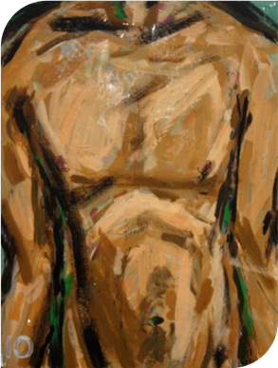  As the clothes were ripped from Jesus, he was stripped of his dignity in front of an irreverent mob. Jesus sacrifices everything. He holds nothing of himself back. Here, on the threshold of death, even more intensely than during his lifetime, he is a being-for-others. He surrenders everything in order to ransom all.  We adore you O Christ, and we praise you, because by your Holy Cross you have redeemed the world
We Name the  Crosses of Today | Look at Jesus and the absolute indignity inflicted upon  him by society. Jesus continues to be stripped of his dignity in those who have their good name taken from them and the intimate details of their lives exposed through the media. Society takes on the role of judge and jury as we curiously devour the details. Jesus is stripped again when men, women and children are portrayed as objects in a pornographic manner in magazines, DVDs, on television and the internet.
We Pray | Forgive us Lord for being an irreverent mob prying into people’s lives. Forgive us for being consumers of gossip under the name of ‘news’. Let us never expose anyone. May we respect the dignity of others and leave judgement to God. Let us see the good in those around us and so enable them to reach their full potential.
 | Lord in Your Mercy
Response: | Hear our Prayer

11: Jesus is Nailed to The Cross

We Remember the Cross of Jesus  Response: | 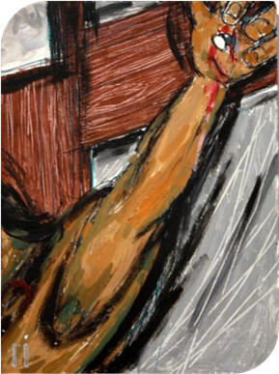  Huge iron nails are hammered  through his wrists and through his  ankles. Iron through human flesh, the flesh must yield, there is no defence. Jesus, nailed to the cross, cannot move. The hand that has wiped blindness from the eyes; the hand that opened the seal of deafness, the hand that touched a heart and cured a leper, the hand that blessed children and those with a disability; the carpenter’s hand is joined to the wood again. As the cross is put in place, he hangs there between us and God, a blood-stained victim for love.  We adore you O Christ, and we praise you, because by your Holy Cross you have redeemed the world
We Name the  Crosses of Today | Jesus continues to be crucified in the ten children  who die every minute of hunger in our world. He is crucified in all who are maimed, damaged and displaced because of war. He is crucified in all who are marginalised in our society because of their race, sexuality or gender. He is crucified in those who are abused physically, sexually or emotionally. He is crucified in those who are trafficked across the world. He is crucified in the exploitation of the earth and its resources.
We Pray | Jesus, we pray on behalf of those who cannot reach out to you at this moment. We pray for all victims of violence; those who suffer it and those who inflict it. We pray especially for children, for the elderly and those too vulnerable to defend themselves. May victims of cruelty and oppression know that you are always with them
 | Lord in Your Mercy
Response: | Hear our Prayer

12: Jesus Dies on The Cross
We Remember the Cross of Jesus  Response: | 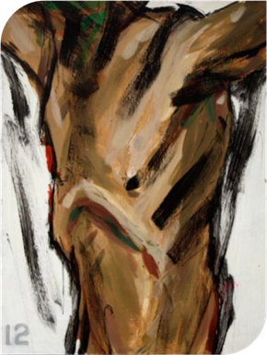  As the life of Jesus ebbs away his  words are not of condemnation or of pity for himself, but of forgiveness; ‘Father forgive them, for they know not what they do’. In the midst of his anguish and suffering Jesus calls upon his Father to forgive those who are putting him to death. This is the real challenge of the cross, forgiveness even of those who hurt us most.  We adore you O Christ, and we praise you, because by your Holy Cross you have redeemed the world
We Name the  Crosses of Today | There is much to seek forgiveness for in our world  today, hunger, poverty, violence, abuse, war, neglect, corruption, the list seems endless. Each one of us praying these stations could continue the list on our own behalf and indeed on behalf of those who have hurt us.  As Jesus dies on Calvary, he challenges us to love our enemies,  to let go of hurt,  to ask for forgiveness  and when we cannot find it in our hearts to forgive,  to ask God to do it for us.  Father, forgive them for they know not what they do.
We Pray | Let us stand with those who watched and prayed in silence  while Jesus breathed his last. As we cannot measure love, so  we cannot dilute this ultimate act of love and forgiveness  with words. Let our love span the silence. Lord! Let our love  and forgiveness speak your praise
 | Lord in Your Mercy
Response: | Hear our Prayer

13: Jesus is Taken Down from the Cross

We Remember the Cross of Jesus  Response: | 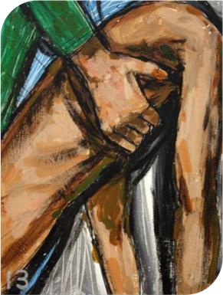  Now Mary takes the broken body of her Son in her arms. In her grief, she remembers the words of her son, over the bread, ‘this is my body, broken, for you,’ and over the wine, ‘this is my blood poured out for you.’ She remembers that little baby in Bethlehem worshipped by shepherds and kings.  She remembers the days when the crowds followed him and she is full of sorrow.  We adore you O Christ, and we praise you, because by your Holy Cross you have redeemed the world
We Name the  Crosses of Today | Mary’s grief is our grief too. As Mary cradles the lifeless  body of her son and offers him back to the Father, she stands with all parents who have held their children close to them in death: those lost through accidents or acts of violence, those who have died by suicide, those who died suddenly or after illness.  Mary grieves with all who sorrow for loved ones: parents, siblings, family members, friends.
We Pray | Help us Lord to accept the partings that must come. Help us to offer our loved ones back to you as Mary offered her son.  Faced with the silence of death, let us not despair but find hope. May the finality of death not oppress us. Help us to trust in you, the Lord of the living and the dead.
 | Lord in Your Mercy
Response: | Hear our Prayer

14: Jesus is Laid in The Tomb

We Remember the Cross of Jesus  Response: | 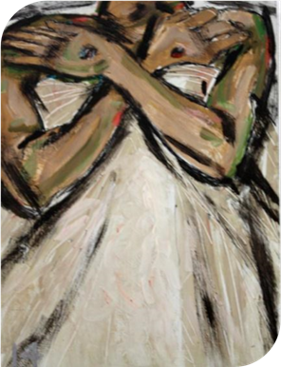  That night his body lay in the dark earth of the world, a seed dying, in the winter of all spirits. All those who had loved him felt emptied and exhausted. There seemed no longer any sense or purpose in anything. But at least no more harm could come to him. They closed the tomb and left.  We adore you O Christ, and we praise you, because by your Holy Cross you have redeemed the world
We Name the  Crosses of Today | There are times when we are overcome by the  darkness of the tomb, by the countless deaths that we experience each day, but the answer to all our grieving and despair lies in this place.  The world is now the tabernacle of God. The grain  of wheat sown in darkness and in death has indeed yielded a rich harvest. Our presence here gives witness to that.  Jesus’ death was not in vain.
We Pray | Jesus, each day you put before us life or death. Help us always to choose life. We pray for all those we have known who have died, and for those who have no one to pray for them. We ask for the gift of faith when we are faced with the darkness of the tomb and our own death approaches. May we have eyes to see the promise of new life that the darkness can hold.
 | Lord in Your Mercy
Response: | Hear our Prayer

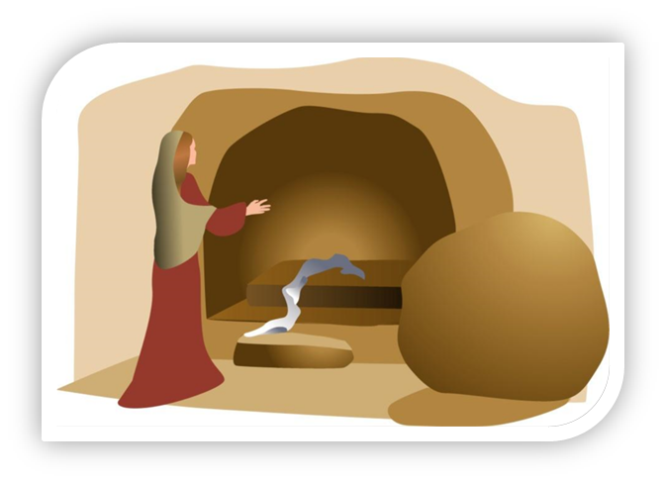

Liturgy from the Faith Development Services Team at Ossory Diocese. Images of the Stations of the Cross that accompany each written reflection are the work of Ken Cooke and were sourced from the Church of St. George the Martyr in Newbury.

